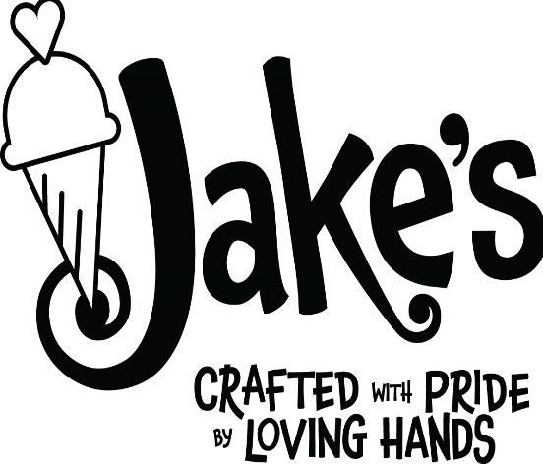
JAKE’S ICE CREAM
6353 COLUMBIA PIKE
FALLS CHURCH, VA 22041
571-378-1855
www.sweetjakesicecream.com
jakesicecream2020@gmail.com

EQUAL EMPLOYMENT OPPORTUNITY
Jake’s Ice Cream provides equal employment opportunities to all employees and applicants for employment without regard to race, color, religion, sex, national origin, age, disability or genetics. In addition to federal law requirements, Jake’s Ice Cream complies with applicable state and local laws governing nondiscrimination in employment in every location in which the company has facilities.

Employment decisions at Jake’s Ice Cream are based on business needs, job requirements and individual qualifications. We are committed to a diverse workforce. We value all employees’ talents and support an environment that is inclusive and respectful.

We reduce work hours between October and March and start increasing them as the business requires over the spring and summer. Existing staff get first choice for expanding their hours. We then hire from our intern pool from Arlington PEP. If we need additional coverage, we will then interview and consider hiring from the general applications we receive.
We review applications on a rolling basis and slots fill up quickly!

SCOOP TEAM APPLICATION
We at Jake’s Ice Cream make excellent and adventurous craft popcorn and confections.
We are a team and we take hiring new staff seriously.
We work very hard to make sure that everyone who enters our doors has the best ice cream experience. Jake’s Ice Cream is about more than just ice cream. It is about the experience, the local community and making people happy! This job is special.

Your name:
Your Cell phone #:
Emergency contact or responsible party name and #:
Email address:

Select one: Yes / No I am open to working whenever needed

Can start (date)________________
Need to end (date) for seasonal employment _________________

Preferred position type:
____ Part time 1 / 2 / 3 / 4 days per week
____ Full time set schedule / flex schedule
____ (?) hours per week
____ I have transportation limitations

Reference(s) for the position:
Name/phone number/ email/ how long did you work there?

Are you already working with the Community Services Board, Service Source or DARS (Department of Aging and Rehabilitative Services)?

Are you on a Medicaid or ID waiver? Do you have limits to the number of hours you can work or total pay you can receive?

Availability on a weekly basis – please write the time ranges between 11:30 AM and 8:30 PM that you are available to work each day. Team shifts will vary depending on whether school is in session and if we are scheduling internships through Arlington or Fairfax Counties. Internships usually start at 10 AM and go until noon. Regular staff does not work when we have interns on site.

Monday: ________________________________
Tuesday: ________________________________
Wednesday: _____________________________
Thursday: _______________________________
Friday: __________________________________
Saturday: ________________________________
Sunday: _________________________________

Note specific dates or date ranges that you will be Unavailable and why:
Please note any clarifications about your schedule – summer hours different from the rest of the year, school schedules, family vacations, camps etc.

Please note: we are open year round and the hours will vary depending on the season and weather.

SHORT ANSWERS to help us get to know you:
- Why do you want to work for Jake’s Ice Cream?

- Which of your past experiences will most help you succeed at Jake’s Ice Cream and why?

- Why do you think you are a great fit for the Scoop Team at Jake’s Ice Cream?

- What does customer service mean to you and why is it important?

- What flavor would you personally love Jake’s Ice Cream to make?

